



**Consolidation of Railroads**

The American railroad system in 1860 consisted of about 30,000 miles of track. Much of the rail lines were in the East and no railroad bridge crossed the Mississippi, Ohio, or Hudson Rivers. Furthermore, a large number of small companies controlled various sections of track, which were often not interconnected. Even if local rail lines had been connected, one company’s cars often would not have been able to travel on another company’s track. There was no standard gauge – or style of track – so the trains of one company did not fit on the track of another. Consequently, when cargo was shipped by train the cargo needed to be unloaded multiple times, requiring new freight charges, additional paperwork, and delay.

After the Civil War, railroad builders took vigorous action to create a more efficient and economical system of rail transportation by ***consolidating***, or combining, small rail lines. Owners of large rail lines often purchased smaller lines or tried to drive them out of business.

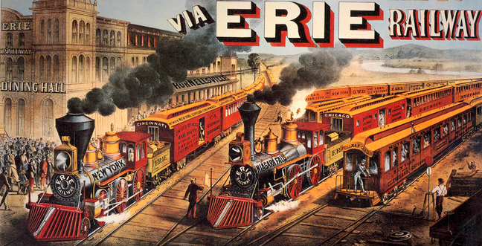

**New York Central Railroad**

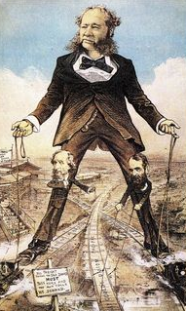The development of the New York Central Railroad proved how railroad ***consolidation***, or combining small lines, would make rail transportation more efficient. In 1866, the New York Central connected Albany and Buffalo. Other railroad lines ran east from Albany to Boston and New York City, and west from Buffalo to Chicago. “Commodore” Cornelius Vanderbilt hoped to unite these lines into one company. He had already made a fortune with a steamship line on the Hudson River, gaining him the title “Commodore.”

Vanderbilt quickly bought up most of the railroad lines linking New York City and Chicago, but the New York Central Railroad held out from being controlled by Vanderbilt. In the winter of 1867, to keep the New York Central from staying in business, Vanderbilt suddenly refused to let passengers and freight from the New York Central line to his railroad lines. With freight and passengers stranded, the New York Central finally gave in to Vanderbilt’s demands. Vanderbilt went on to purchase additional railroad lines from Chicago to New York City. At the time of his death in 1877, Vanderbilt controlled 4,500 miles of integrated railroad connecting New York City and the Great Lakes Region.

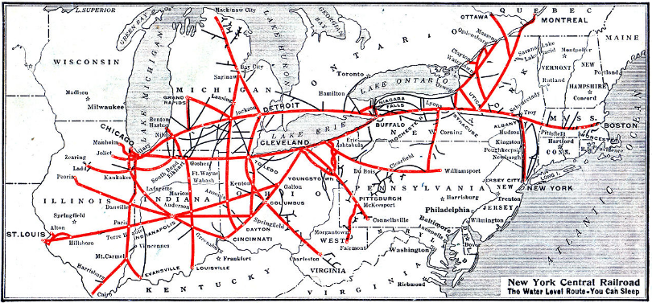

**Effects of Railroad Consolidation**

Railroad ***consolidation***, the combining of small railroad lines, often led to more efficient rail service despite the rough and tumble competition between railroad companies (Vanderbilt vs. New York Central Railroad). By 1886, the railroads had adopted a standard gauge – meaning a rail car could be used on any railroad line. Passengers and railroad freight could travel longer distances without stopping.

***Rates***, or charges, also dropped dramatically. By the end of the 1800s passenger fares reduced by half, and freight charges also dropped. Due to the standard gauge, freight was loaded on a rail car in Chicago and then it wasn’t unloaded until it reached its destination in New York City. This allowed shippers to pay only one fare for the whole distance.

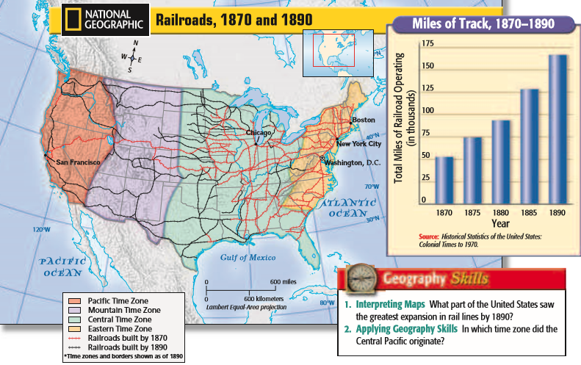

**Time Zones**

By 1883, railroad ***consolidation***, the combining of small railroad lines, made efficient shipping essential to the nation’s economy. The American Railway Association chose to divide the United States into four time zones that exist today: Easter, Central, Mountain, and Pacific.

Before time zones were created, every town kept its own time, which often varied by several minutes from the time being kept in a neighboring town. There variations made it difficult for the railroads to establish uniform schedules. The creation of the time zone system simplified scheduling and improved efficiency.

